**TEST SUITE LAUNCH STEPS**

**NOTE: If Visual Studio 2017 is not available on your computer I shall demonstrate the Test from my system over ZOOM Video call**

1. **Create Folder structure “C:\Users\Vasudha\source\repos\HeroKoTestingProj\”**
2. **Download project to above folder from GitHub location**

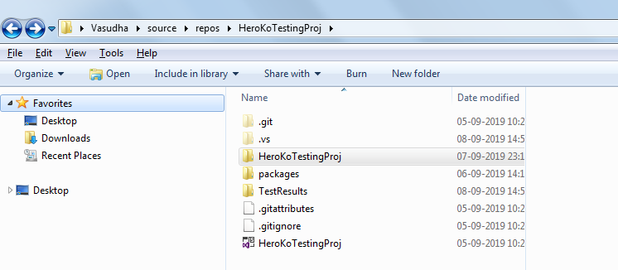

1. **Double click on” HeroKoTestingProj” to open the project in Visual Studio 2017**
2. **When its opened looks as below**

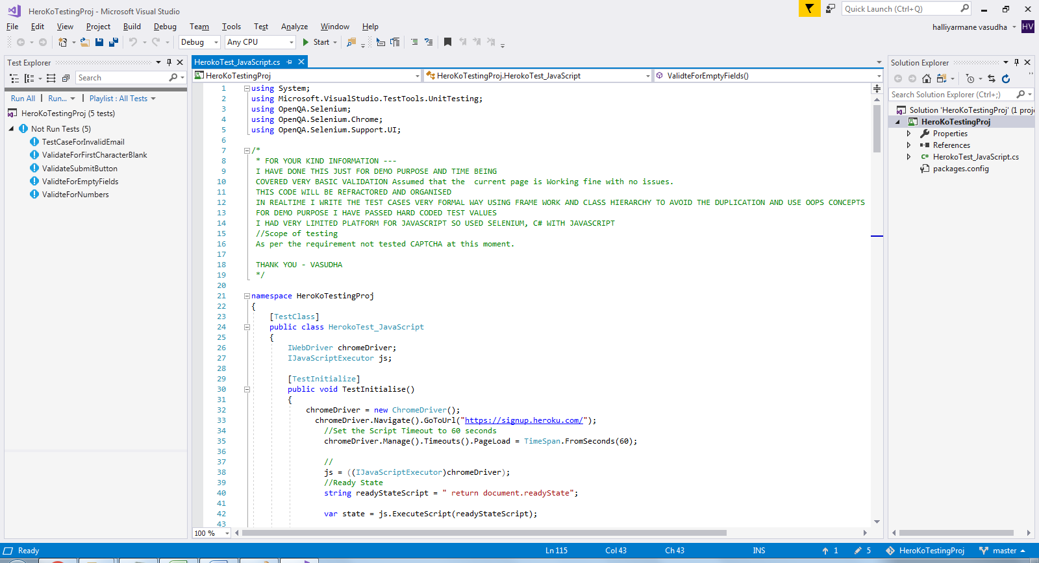

1. **Click on ‘Test’ Menu and open’Windows 🡪 Test Explorer window, Which opens Test Explorer with all the Test Scripts on the Left Hand Side.**
2. **Run Tests one by one and verify Results**
3. **The Test Result Panel looks as below**
4. 